**Analysis and Prediction of Profitable Web Shopping**

**ABSTRACT:**

E-commerce is a process of buying and selling of products or services, making money transfer and transferring data over electronic medium. Ecommerce has evolved to make products easier to discover and purchase through online retailers and marketplaces. Food Products sector is the largest retail category. There are many leading food ecommerce sites available in the market, which leads to high competition among food retailers. Online food retailers face many problems like coming new trends, food quality, etc. because of this the sales graphs fluctuates. Hence there is a wide need for sales prediction system. And that’s exactly the problem companies struggle with collecting data. To overcome this problem, we have proposed an ecommerce food products sales forecasting system which helps by maintaining the previous sales data and on the basis of previous sales it predicts the upcoming year sales. There are 2 modules in this sales forecasting software namely, Admin and User. Admin can add products and view products; list of users and users order and view the generated sales predictive analysis report. Users can view the products added by admin, he/she can add products to cart for buying purpose. He/she can track the order and view the previous order history.

**ARCHITECTURE:** 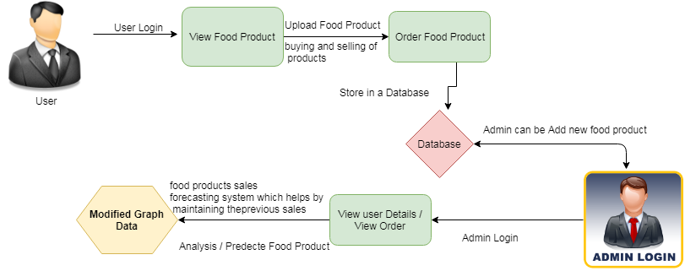

1. COMPONENT DIAGRAM
   1. User

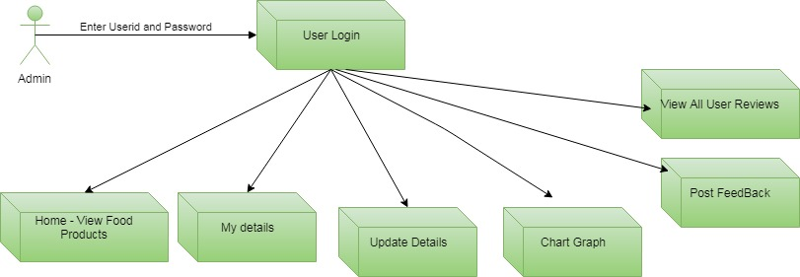

* 1. Admin

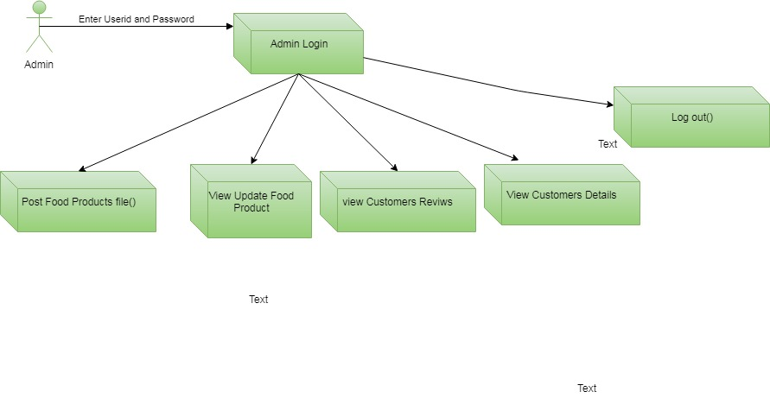

1. ER DIAGRAM
   1. User

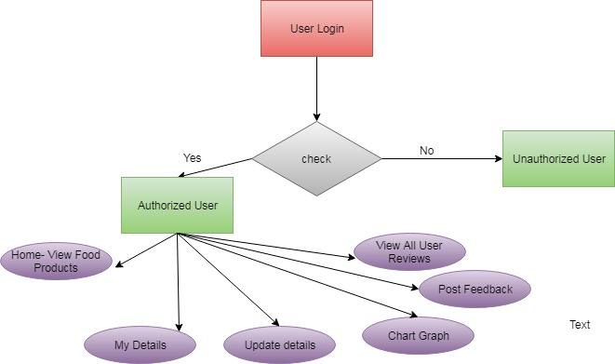

* 1. Admin

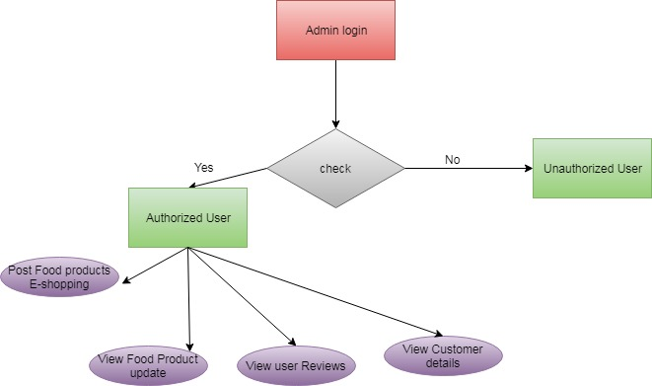

1. USE CASE DIAGRAM
   1. User

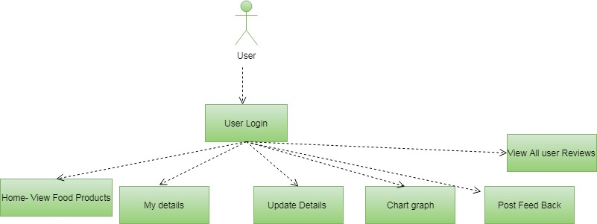

* 1. Admin

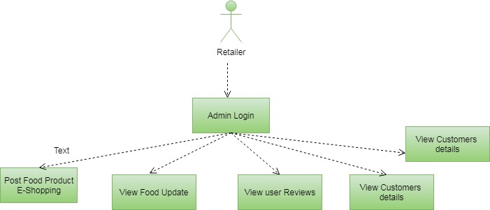

1. CLASS DIAGRAM

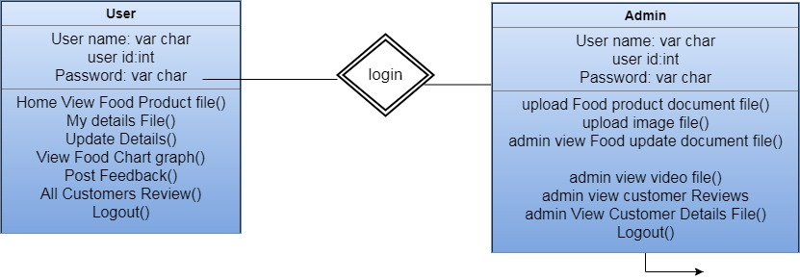

1. DATA FLOW DIAGRAM
   1. User

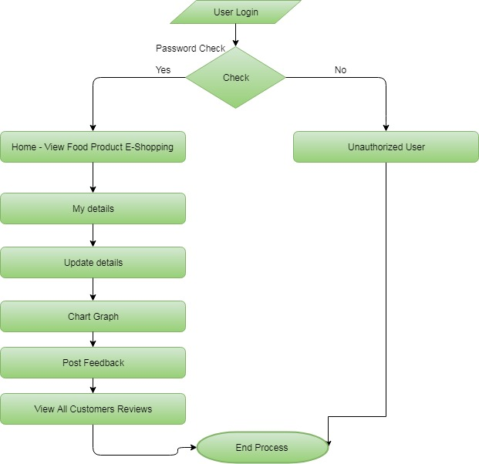

* 1. Admin

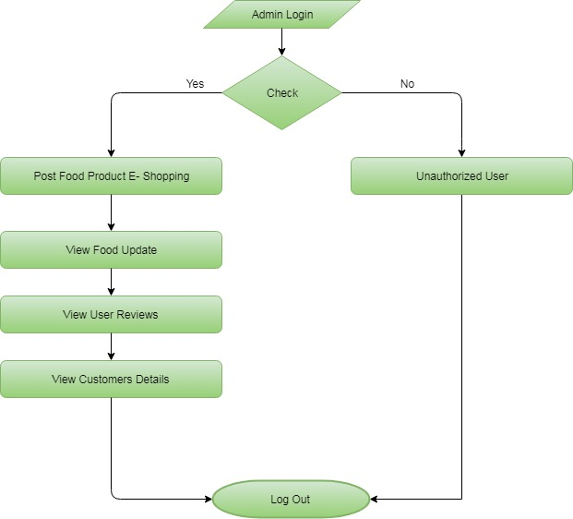

1. ACTIVITY DIAGRAM
   1. User

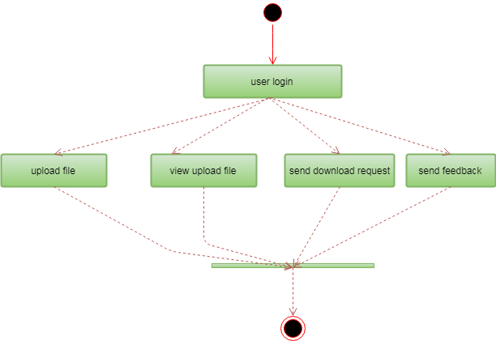

* 1. Admin

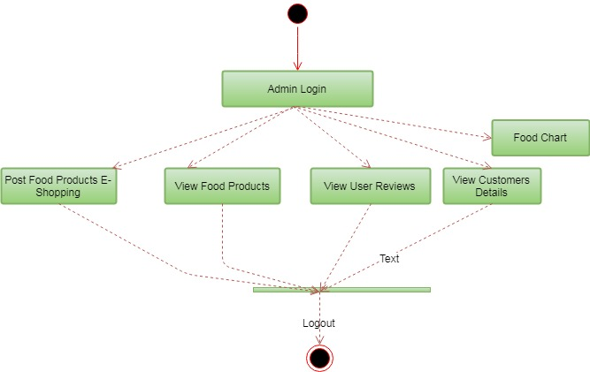

1. SEQUENCE DIAGRAM
   1. User

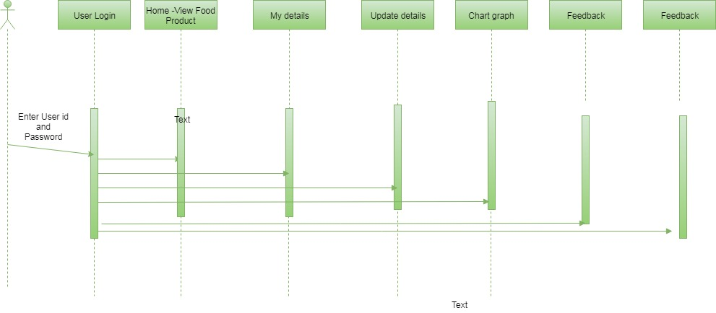

* 1. Admin

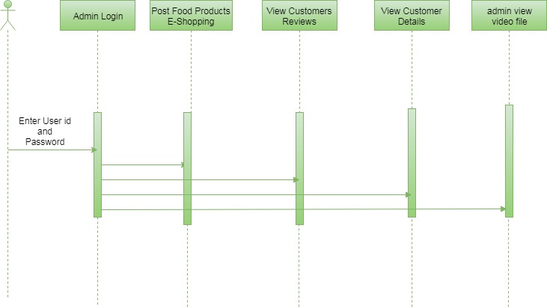

**EXISTING SYSTEM:**

## Any one, good or bad, can easily start a business. And there are many bad sites which eat up customers’ money. There is no guarantee of product quality. Mechanical failures can cause unpredictable effects on the total processes. As there is minimum chance of direct customer to company interactions, customer loyalty is always on a check. Ease of use is the prime reason that drives the success of e-commerce. Though internet provides a quick and easy way to purchase a product, some people prefer to use this technology only in a limited way. They regard internet as a means for gathering more information about a product before buying it in a shop. Some people also fear that they might get addicted to online shopping. Long duration and lack of proper inventory management result in delays in shipment. Though the duration of selecting, buying and paying for an online product may not take more than 15 minutes; the delivery of the product to customer’ s doorstep takes about 1-3 weeks. This frustrates the customer and prevents them from shopping online. The traditional shopping exercise provides lot of fun in the form of show-room atmosphere, smart sales attendants, scent and sounds that cannot be experienced through a website. Indians generally enjoy shopping. Consumers look forward to it as an opportunity to go out and shop.

## DISADVANTAGES:

## There are many hackers who look for opportunities, and

## thus an ecommerce site, service, payment gateways, all are always prone to attack.

.

**PROPOSED SYSTEM:**

Due to rapid growth of technology, business organizations have switched over from the traditional method of selling goods to electronic method of selling goods. Business organizations use internet as a main vehicle to conduct commercial transactions. Customers can purchase items from the comfort of their own homes or work place. Shopping is made easier and convenient for the customer through internet. It is also easy to cancel the transactions. To attract customers to shop online, and marketers offer Faster buying/selling procedure, as well as easy to find products. Buying/selling 24/7. Customers can easily select products from different providers without moving around physically discounts to the customers. Due to elimination of maintenance, real-estate cost, the retailers are able to sell the products with attractive discounts through online. Sometimes, large online shopping sites offer store comparison. Customers can purchase items from the comfort of their own homes or work place. Shopping is made easier and convenient for the customer through internet. It is also easy to cancel the transactions.

## ADVANTAGES

1. Faster buying/selling procedure, as well as easy to find products.
2. Buying/selling 24/7
3. Low operational costs and better quality of services..

**MODULES:**

1. **Upload Food Product**

An important aspect of starting an Online Business is adding and listing your products. Depending on the products you are selling, you can create a suitable product page with details and variants, amongst other things. Let us go through the steps to configure products on your Jumpseller Store..

1. **Sale Products Prediction**

“Prediction” refers to the output of an algritham after it has been trained on a historical dataset and applied to new data when you’re trying to forecast the likelihood of a particular outcome, such as whether or not a customer will churn in 30 days. The algorithm will generate probable values for an unknown variable for each record in the new data, allowing the model builder to identify what that value will most likely be.

1. **Graphical Representations**

The analyses of proposed systems are calculated based on the approvals and disapprovals. This can be measured with the help of graphical notations such as pie chart, bar chart and line chart. The data can be given in a dynamical data.

1. **Verify feedback**

There have been so many positive recommendations of the value of feedback for ecommerce, that the case doesn’t really need to be made anymore, though I’ll make it again anyway Quite simply, user reviews increase conversions.

**ALGORITHM:**

**Support Vector Machine**

“Support Vector Machine” (SVM) is a supervised machine learning algorithm which can be used for both classification or regression challenges. However, it is mostly used in classification problems. In this algorithm, we plot each data item as a point in n-dimensional space (where n is number of features you have) with the value of each feature being the value of a particular coordinate. Then, we perform classification by finding the hyper-plane that differentiate the two classes very well (look at the below snapshot). The SVM algorithm is implemented in practice using a kernel. The learning of the hyperplane in linear SVM is done by transforming the problem using some linear algebra, which is out of the scope of this introduction to SVM. A powerful insight is that the linear SVM can be rephrased using the inner product of any two given observations, rather than the observations themselves. The inner product between two vectors is the sum of the multiplication of each pair of input values. For example, the inner product of the vectors [2, 3] and [5, 6] is 2*5 + 3*6 or 28. The equation for making a prediction for a new input using the dot product between the input (x) and each support vector (xi) is calculated as follows:

f(x) = B0 + sum(ai * (x,xi))

This is an equation that involves calculating the inner products of a new input vector (x) with all support vectors in training data. The coefficients B0 and ai (for each input) must be estimated from the training data by the learning algorithm.

**REQUIREMENT ANALYSIS**

The project involved analyzing the design of few applications so as to make the application more users friendly. To do so, it was really important to keep the navigations from one screen to the other well ordered and at the same time reducing the amount of typing the user needs to do. In order to make the application more accessible, the browser version had to be chosen so that it is compatible with most of the Browsers.

**REQUIREMENT SPECIFICATION**

**Functional Requirements**

* Graphical User interface with the User.

**Software Requirements**

For developing the application the following are the Software Requirements:

1. Python
2. Django
3. MySql
4. MySqlclient
5. WampServer 2.4

**Operating Systems supported**

1. Windows 7
2. Windows XP
3. Windows 8

**Technologies and Languages used to Develop**

1. Python

**Debugger and Emulator**

* Any Browser (Particularly Chrome)

**Hardware Requirements**

For developing the application the following are the Hardware Requirements:

* Processor: Pentium IV or higher
* RAM: 256 MB
* Space on Hard Disk: minimum 512MB

**CONCLUSION**

After careful oberservation, it has come to my conclusion that e-commerce has undeniably become an important part of our society. The world wide web is and will have a large part in our daily lives. It is therefore critical that small businesses have their own to keep in competition with the larger websites. Since web developers have lowered down the prices for their services, it has become more affordable for small businesses to use the world wide web to sell their products. Although there are negative aspects of e-commerce, small businesses have tried to accommodate to the needs of the consumers. For example, one of the negative aspects of e-commerce is that consumers lack the advice and guidance of sellers, to accommodate that, they have customer service through the phone of online to answer any questions. It is also important to note that e-commerce does not benefit all small companies equally. How much revenue a business gets from e-commerce depends on what kind of service it gives. For example, most people would like to try on clothes before they buy them, so it probably would not benefit a small business that sells clothes as much as a small business that sells home supplies or specialty books. Nevertheless, e-commerce does benefit any business even in small ways. This is why it is crucial to understand how e-commerce affects small businesses because it is becoming such a huge part of how society functions that it effects the economy greatly and whatever happens to the economy affects us. This is why is it important to understand this subject because in the long run, it will affect all of us.